Recent changes in clinical trials across the globe

Feb 08th 2022 Observations

**Table of Content**

1. **Introduction 2**
2. **Top 10 Trial Conditions for 2 years** **2**
3. **Distribution of Source Register across Study types for 2 years** **5**
4. **Distribution of Source Register across Trial Conditions for 2 years** **8**
5. **Flow of Trials across Sources to Study types to Conditions for 2 years** **11**

# Introduction

With reference to WHO’s ICTRP dataset for the last 2 years and performed 2 times in the time range of a week.

# Top 10 Trial Conditions for 2 years

**Analysis Performed on 8th Feb, 2022** 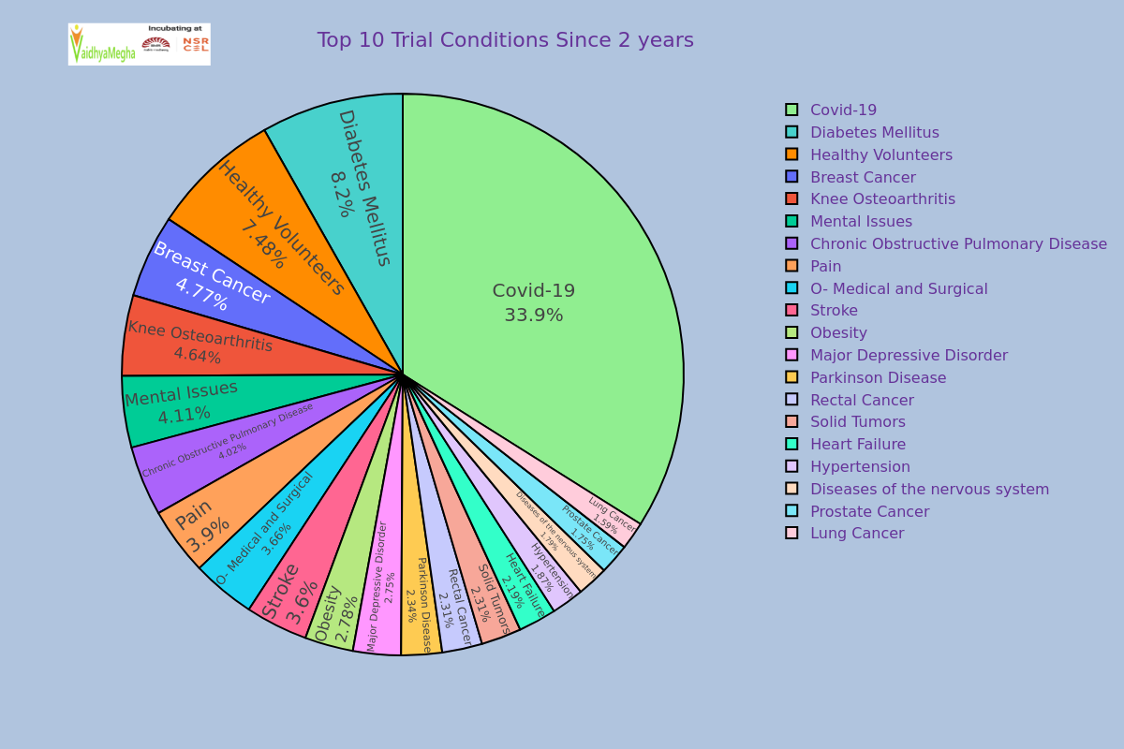

**Analysis Performed on 1st Feb, 2022** 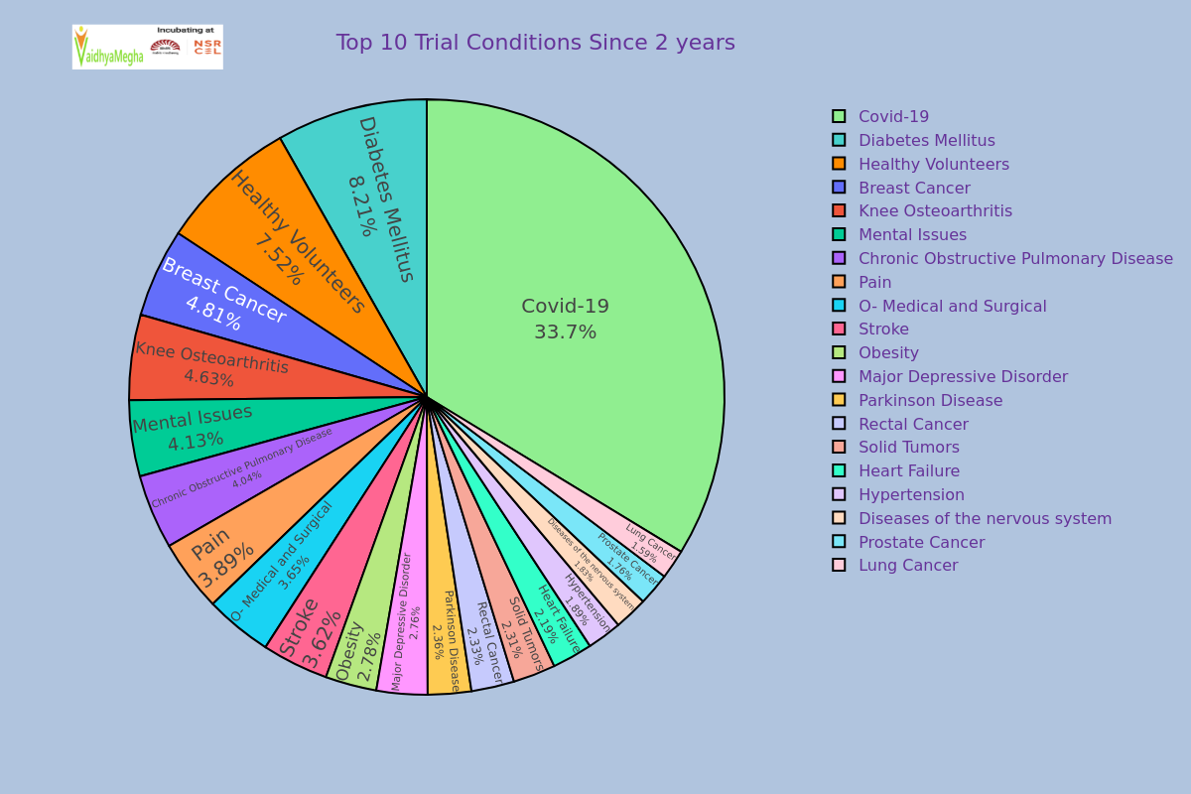

By seeing above two charts of analysis which were performed on 8th Feb 2022 and 1st Feb 2022 , we can observe that the changes of percentages of some trials in a week approximately.

| **S. No.** | **Trial Condition** | **% Of first analysis** | **% Of second analysis** | **Remarks** |
| --- | --- | --- | --- | --- |
| 1 | Covid -19 | 33.9 | 33.7 | Increased by 0.2% |
| 2 | Diabetes Mellitus | 8.20 | 8.21 | Decreased by 0.1% |
| 3 | Healthy Volunteers | 7.48 | 7.52 | Decreased by 04% |
| 4 | Breast Cancer | 4.77 | 4.81 | Decreased by 0.4% |
| 5 | Knee Osteoarthritis | 4.64 | 4.63 | Decreased by 01% |
| 6 | Mental Issues | 4.11 | 4.13 | Decreased by 02% |
| 7 | Chronic Obstructive Pulmonary Diseases | 42 | 44 | Decreased by 02% |
| 8 | Pain | 3.90 | 3.89 | Increased by 01% |
| 9 | O- Medical and Surgical | 3.66 | 3.65 | Increased by 01% |
| 10 | Stroke | 3.60 | 3.62 | Decreased by 02% |

From the above there is a 0.2% increment in Covid-19 and 0.1% increment in Pain and O- Medical and Surgical trial conditions.

# Distribution of Source Register across Study types for 2 years

**Analysis Performed on 8th Feb, 2022** 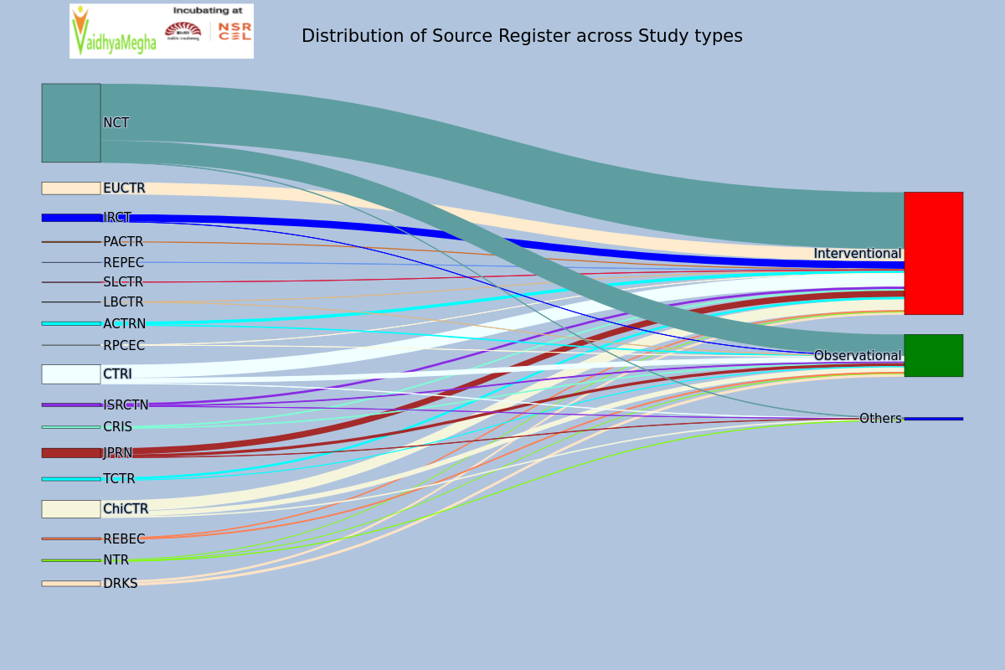

**Analysis Performed on 1st Feb, 2022** 

| **S.No** | **Source Register** | **Interventional** | **Observational** | **Others** |
| --- | --- | --- | --- | --- |
| 1 | ACTRN | 25 | 3 |  |
| 2 | CRIS | -36 | -4 |  |
| 3 | CTRI | -102 | -45 | -1 |
| 4 | ChiCTR | -47 | -22 | -17 |
| 5 | DRKS | -22 | -18 |  |
| 6 | EUCTR | -20 |  |  |
| 7 | IRCT | -103 | 0 |  |
| 8 | ISRCTN | -4 | 4 | -1 |
| 9 | JPRN | -89 | -42 | -5 |
| 10 | LBCTR | -1 | 0 |  |
| 11 | NCT | -467 | -149 | -6 |
| 12 | NTR | -12 | -10 | 0 |
| 13 | PACTR | -7 |  |  |
| 14 | REBEC | -44 | -3 |  |
| 15 | REPEC | -1 |  |  |
| 16 | RPCEC | 0 | 0 |  |
| 17 | SLCTR | -1 |  |  |
| 18 | TCTR | -14 | -6 |  |

The above table represents the changes in clinical trials registrations in a week approximately.

# Distribution of Source Register across Trial Conditions for 2 years

**Analysis Performed on 8th Feb, 2022** 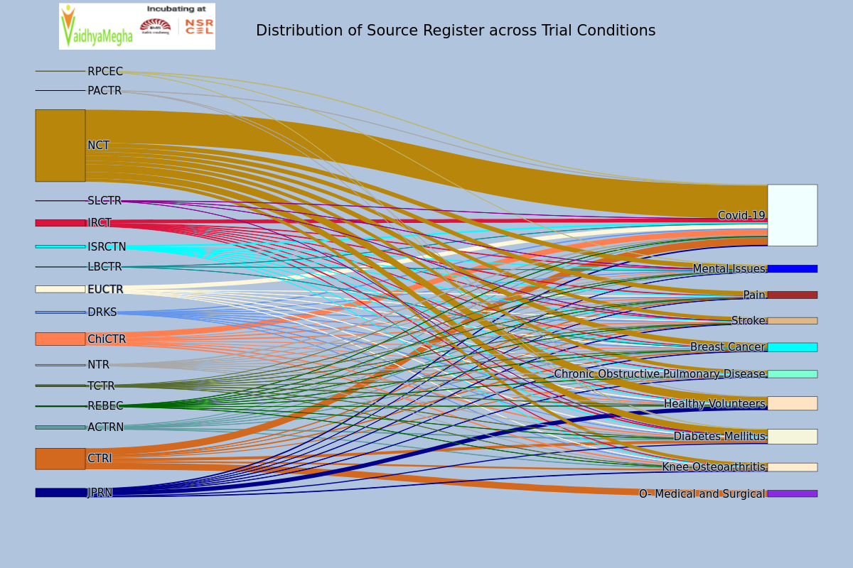

**Analysis Performed on 1st Feb, 2022** 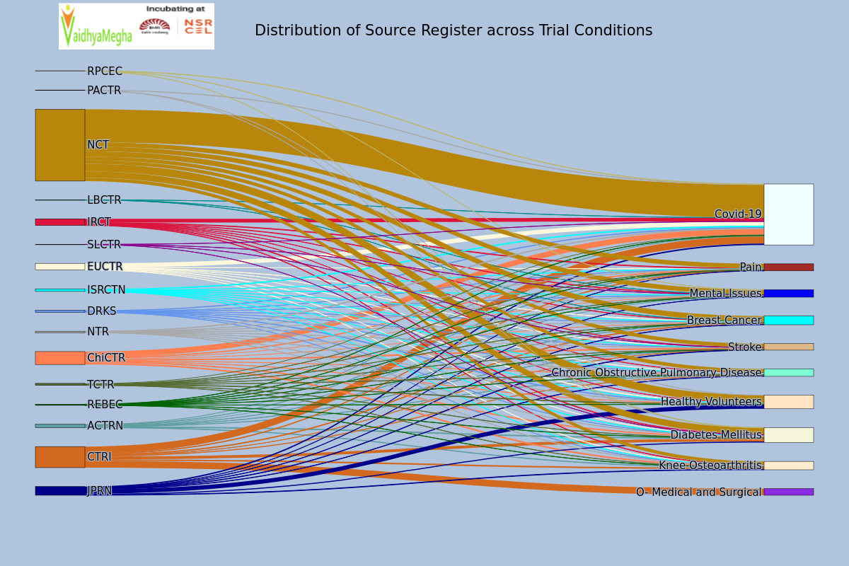

| **Source Register** | **Breast Cancer** | **Chronic Obstructive Pulmonary Disease** | **Covid-19** | **Diabetes Mellitus** | **Healthy Volunteers** | **Knee Osteoa-rthritis** | **Mental Issues** | **O- Medical and Surgical** | **Pain** | **Stroke** |
| --- | --- | --- | --- | --- | --- | --- | --- | --- | --- | --- |
| ACTRN | 0 | 0 | 2 | 1 |  | -1 | 1 |  | 4 | -2 |
| CTRI | -1 | -2 | 0 | -5 |  | -1 |  | -4 | -2 | 0 |
| ChiCTR | 0 | 0 | -15 | -2 | 0 | -2 | 0 |  | 0 | -2 |
| DRKS | 0 | 0 | 0 | 0 | -1 | -1 | 0 |  | 0 | 0 |
| EUCTR | 0 | 0 | 2 | -1 | 0 | 0 |  |  | 0 | 0 |
| IRCT | 0 | 0 | 0 | -2 | 0 | -1 | -2 |  | -1 | 0 |
| ISRCTN | 0 | -1 | 6 | 0 | 0 | 0 | 0 |  | 0 | 0 |
| JPRN | 0 | 0 | 0 | -1 | -17 | 0 | -4 |  | -1 | -1 |
| LBCTR | 0 |  | 0 |  |  |  | 0 |  |  |  |
| NCT | -18 | -9 | 4 | -8 | -7 | -1 | -7 |  | -7 | -6 |
| NTR | 0 | 0 | 0 | 0 | 0 | 0 | 0 |  | 0 | -1 |
| PACTR |  |  | 0 | 0 | 0 |  |  |  |  |  |
| REBEC | 0 | 0 | 0 | -2 | 0 | 0 | 0 |  | 0 | 0 |
| RPCEC |  |  | 0 | 0 |  |  | 0 |  |  |  |
| SLCTR |  |  | 0 | 0 |  |  | 0 |  |  | 0 |
| TCTR | 0 | 0 | 0 | 0 | -1 | 0 | 0 |  | 0 | 0 |

The above table represents the increment in clinical trials registrations in a week approximately. From the above table, clinical trials on Covid-19 were registered from almost every Source. Diabetes Mellitus , Psychological problems and Stroke are also health issues in almost every nation.

# Flow of Trials across Sources to Study types to Conditions for 2 years

**Analysis Performed on 8th Feb, 2022** 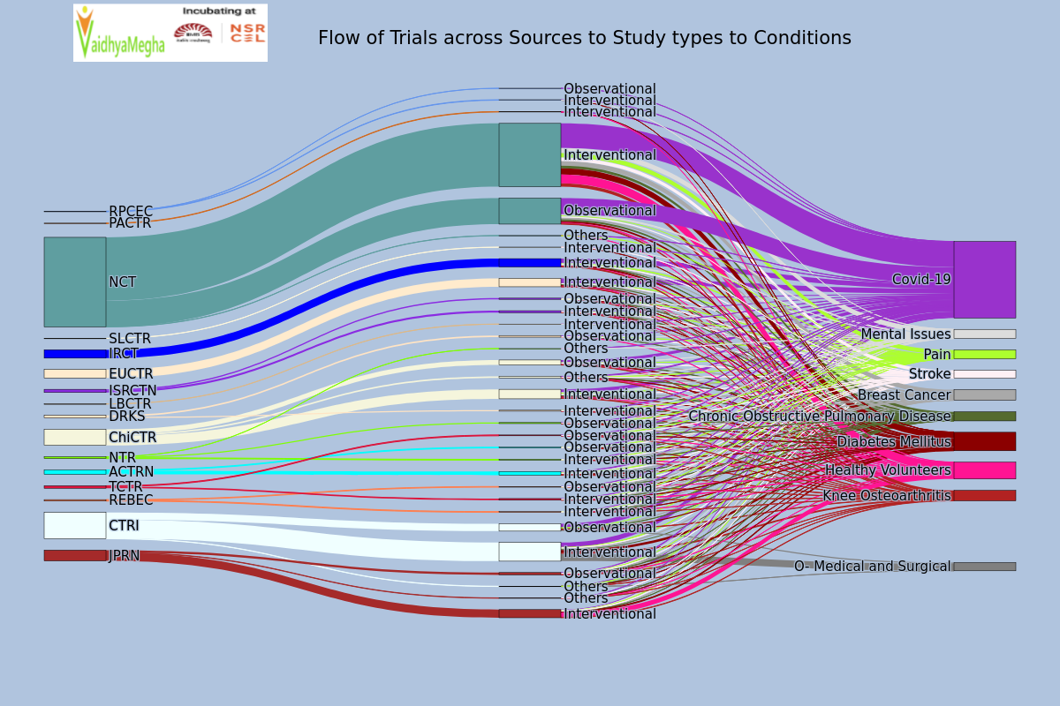

**Analysis Performed on 1st Feb, 2022** 